# Computational Finance

### 18 Feb 2020

#### Returns

We can evaluate returns based on a time series of prices, denoted as . For instance,

We can consider returns as . It is important to note the asymmetry here, as if we were to take an example, with , then consequently if we were to flip the values for .

#### Multiperiod Returns

Returns over multiple time steps are a product rather than a sum, and this could be demonstrated with an example over 4 time steps, where . The returns would yield . This does not sum to 0.6, but in fact the product still yields the correct values.

#### Return on a Portfolio

Assuming assets (google, gold, USD, etc...) with an allocation of where , and

Presuming as capital, your set up is , which evaluates to

#### Annualizing Returns

This creates a standard to compare return rates. You can consider monthly vs yearly.

Where , where

Or you can do . Note here that instead of 365, 300 is used. This is a variation within the field, having values such as 250, 275, 300, 365, etc... (My best guess to why this is the case is because we are going off the presumption that we are not trading every day)

Notice that we use exponential to take into account the notion of compounding.

#### Value of Money

To answer the question of “how much is one dollar today worth tomorrow?” We need to look at the frequency of returns.

Consider:

, the future value, denoted

, the future value, denoted

, the future value, denoted

Generalized as , where is the current value.

There is a theoretical consideration here where we consider the returns to be continuous, allowing us to use limits, which results in our calculations to come to:

(We can kind of remember vaguely something similar to this when we originally calculated compounding interest)

It is not considered realistic in practice however.

Note that this formula also allows for a symmetry (whereas the multiperiod returns before do not).

Multiperiod Continuous returns are additive.

#### Book-keeping

It is done in the format , for instance, or . The indicates the BUY, and the indicates the SELL.

Note that in the market, there is not a singular price for any given item, but rather a ASK and a BID price. Meaning that BUY and SELL prices are marked differently. The difference between the ASK and BID price is called the spread.

### 25 Feb 2020

There’s a website that simulates a market that could be interesting to play with some of the concepts: oanda

#### Modeling in Time Series analysis (and it’s not what you think)

When taking a look at a time series, we might want to consider values of interest of points of analysis such as mean (expected value), variance, standard deviation, and even things like monthly return, etc... These factors are what are taken into account when we talk about “modeling”.

It is important to separate the terminology of “modeling” with “prediction” since in the finance world, we are not talking about the same thing. The difference here is that the model speaks to nothing about the future or attempts to make a “prediction” like we think about in regular machine learning, but rather, we are talking about a descriptor or an explanation of the current data that we have.

#### Stationary is a pre-requisite in Modeling

When looking at time series analysis and modeling, it might be counter intuitive to consider the fact that we make some assumptions or even manipulate what we take into account in our analysis in order to “fix” or make stationary the data. We are not looking at trends (upwards increase that is somewhat linear) nor are we looking at the seasonalities of the data (some sort of up and down with regards to time). That is not to say that we don’t care about patterns, but rather more importantly,

#### We are looking beyond at patterns which are a function of time

This means that we fix properties about the time series. The two conditions for our stationary property is:

1. Meaning that the average is the same along the time series.

2. Meaning that the variance is the same with regards to any points.

One of the very good examples that highlight this type of “fixing” or stationary property is to look at a time series with a upwards trend:

//see the paper notes

and see that when we take the monthly returns and look at the data that originally had an upwards trend, to notice that we sort of “removed” this upwards trend when we take the monthly returns. Essentially, we are attempting to find a pattern in the data, or descriptor in the data that is not a function of time (intuition might be to understand that obviously things will increase or decrease, but perhaps we are more worried about HOW they increase or decrease, or even maybe WHY they could increase decrease).

#### Autocorrelation of a Model in order to find (hidden) patterns

The autoregressive model gives us the concept of an autocorrelation, which when we formalize into the autocorrelation function, gives us a tool to analyze the (hidden) patterns of our data. We can take a time series, and view its autocorrelation function. It is useful to see the paper notes images regarding this part.

### 03 Mar 2020

(Note: Only attended half lecture this week, since wanted to take a break and see crowdsourcing. Maybe something I will regret later, but my gut tells me to keep taking finance.)

#### We have to consider the question of whether or not the market is “efficient”

What we mean by this comes from economic theory from way back in the hay days, where the theory suggested that the market is always right (ball don’t lie, markets edition). It suggests that the market is rational, and it is impossible to beat the market in terms of gains/losses, since nothing is obtained at above or under value (what it is is reality, and the market reflects that).

#### This framework is separated into three categories: weak, semi, and strong

Of course, it means how strictly we apply these logics and the framework.

Weak suggests that history will not give you additional ability to predict the future, since price is always right. Analysis is inefficient and price is a random walk.

Semi suggests that new info is reflected (immediately) in the prices

Strong suggests that any new info, whether public or private is immediately reflected in the price.

#### There exists lots of counter arguments and frameworks, they are also valid

Which begs the question of whether or not we can ever really know what the hell is going on. And the answer is “probably not”.

#### Stock Exchanges comes in two flavors: regulated or loosely-regulated

We can think about places like the NYSE (New York Stock Exchange, empire state, the big apple, babyyyyy) or LSE (London Stock Exchange, the boys o’er yonder the pond) or Tokyo Stock Exchange (arigathank you). These are usually physical places, and are heavily regulated. They have a clearing process (meaning that they frequently check accounts to make sure funds are available, etc...)

Electronic trading has become more of a thing, and so the next variety of stock exchanges are more loosely-regulated, and they are called “Over the Counter” stock exchanges. These are typically websites or hosts, and they are less formal and less regulated. There might be a market maker that proposes quotes, and these makers are generally paid for the risk, meaning they have an inventory. Comparatively, these OTCs generally have way less transparency.

#### There are different types of Assets

Equity – is a share in a company, dividends are periodically paid, and essentially an investment in the company.

Bonds – are essentially loans to central banks. They are agreed upon the maturity of the bond and the payout scheme.

Commodities – can also be bought and traded. But since we don’t want an actual pile of corn, they have a system of trades called “Futures” meaning it suggests that “in X amount of time, you will buy the commodity”. If I understand this correctly, it’s essentially virtualizing the commodities by giving an intent to purchase a commodity and putting down the money (which in the finance world means you essentially own it now) and later on when the price rises/drops you are responsible for that “share” of the crops/commodities. I guess maybe you can think stocks except instead of stocks is some pile of commodities somewhere.

Currency – these are the backbone of the market, since they are involved in someway in every trade (currency interest rate on exchange). Comes in pairs (BUY SELL) like we mentioned before. The interest rate on exchange will differ, and that’s where a lot of the money needs to be concerned.

### 10 Mar 2020

#### Reality makes it hard to think about data in equidistant, continuous, time

Therefore we have to have some way to discretize them, since prices can jump, spreads can shift, etc. In essence, we have to take a continuous line and discretize them in some way (check the notes diagram).

We can also interpolate from discretized data, but know that in doing so we are making some strong assumptions regarding the data. Our goal is to smooth the time series, and there are some methods to achieve that.

#### Moving Average (MA) is a technique for smoothing averages

Imagine of values. The moving average can be formalized as following:

So it is quite literally an average, but of course “moving” in the sense that it is not an average of all the data, it is an average of a snapshot. We can think about it as a “local mean” of an image using block sizes if we wanted to make a relation to some of our other classes.

Notice that because of the way we define this MA, it is sensitive to lag, but also more importantly, it is sensitive to the loss of outliers from the current moving average. Since we want our MA to change or “react” (as professor depuis says) to the incoming data (even if it is an outlier of sorts), but once that data leaves the moving average, we don’t really want our MA to spike to react to something leaving. Therefore, we can introduce a Weighted Moving Average (as all things are).

#### The Weighted Moving Average solves the problem of older data spikes

It is defined as:

However, in practice, the weighting doesn’t really practically give us what we want, so they take the idea and reformat it to be an exponential moving average.

#### The Exponential Moving Average is like the weighted moving average, but it is more practical

It is defined:

We can simplify and ensure that Thus we can rewrite :

Almost defining it in a recursive way, allowing for simpler calcs by storage methods.

(We can check the paper notes for a small graph showing the graphical behavior of the moving averages)

#### We can determine in some methodology

- We can choose a time period, and then apply the formula , where N is the number of time units. We obtained this from some estimation from the EMA.

- Choose the impact value at a time , (say, 1% after 100 time steps) and then calculate some value of accordingly.

Graphically, this is what we can sort of see regarding the moving averages. We can change and shift the MA to get smoother values, or sharper values, and that will tell us more or less about what we want to know. The main idea here is that it is of course, always a trade off of sorts.

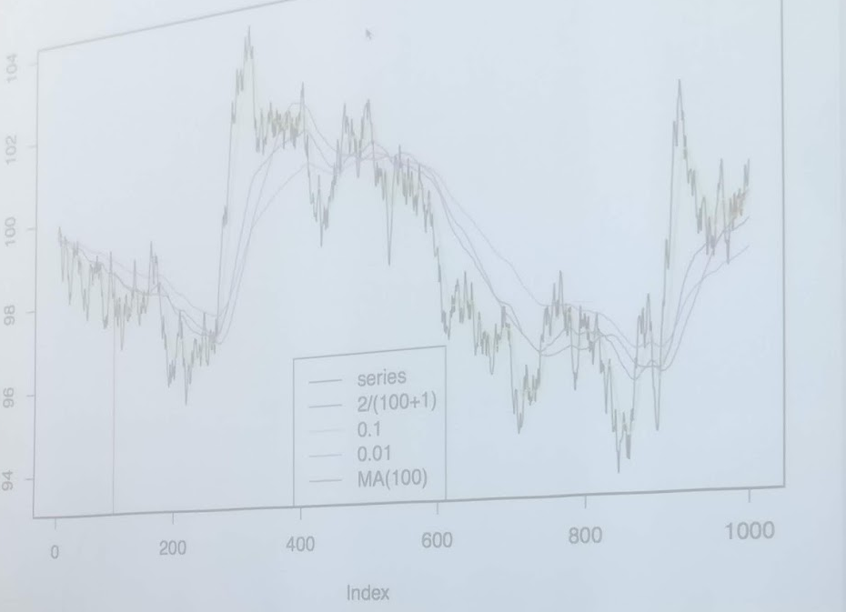

(we skip some next stuff that doesn’t really make that much sense to us quite yet... check the paper notes before intrinsic time and after the graph)

#### Intrinsic Time: what if time is not time-based but event-based?

We can consider a margin or scale (say 1%) and then we follow changes in the price, and see if any changes in the price reflect greater than this margin. If it does, we consider it an event worthy of basing our time on.

This is important since physical time could in certain cases “miss” big spikes and events because of the natural of how they are recorded.

Some important factors for us: directional change, and overshoot. Directional change just means that the direction (up or down) changed, which is an important event for us. Additionally, we expect values to rise and drop, rise and drop, we don’t expect multiple rises or drops in succession really, and so when it occurs, we call this the “overshoot.” And looking at it could tell us some things about the state of the market.